CERTIFICATE OF APPRECIATION
Awarded to
______________________
Name

________________________________________
Department
For dedication and commitment to quality service as a Student Employee
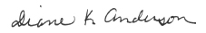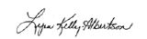
Vice President for Student Affairs Career and Student Employment Services

Supervisor

Date

