Come to an Information Session on a faculty-led Study Abroad course!

INTL 4980 International Development and Community Service in Peru

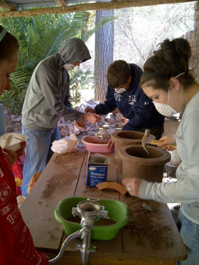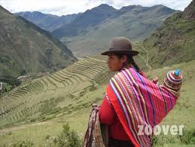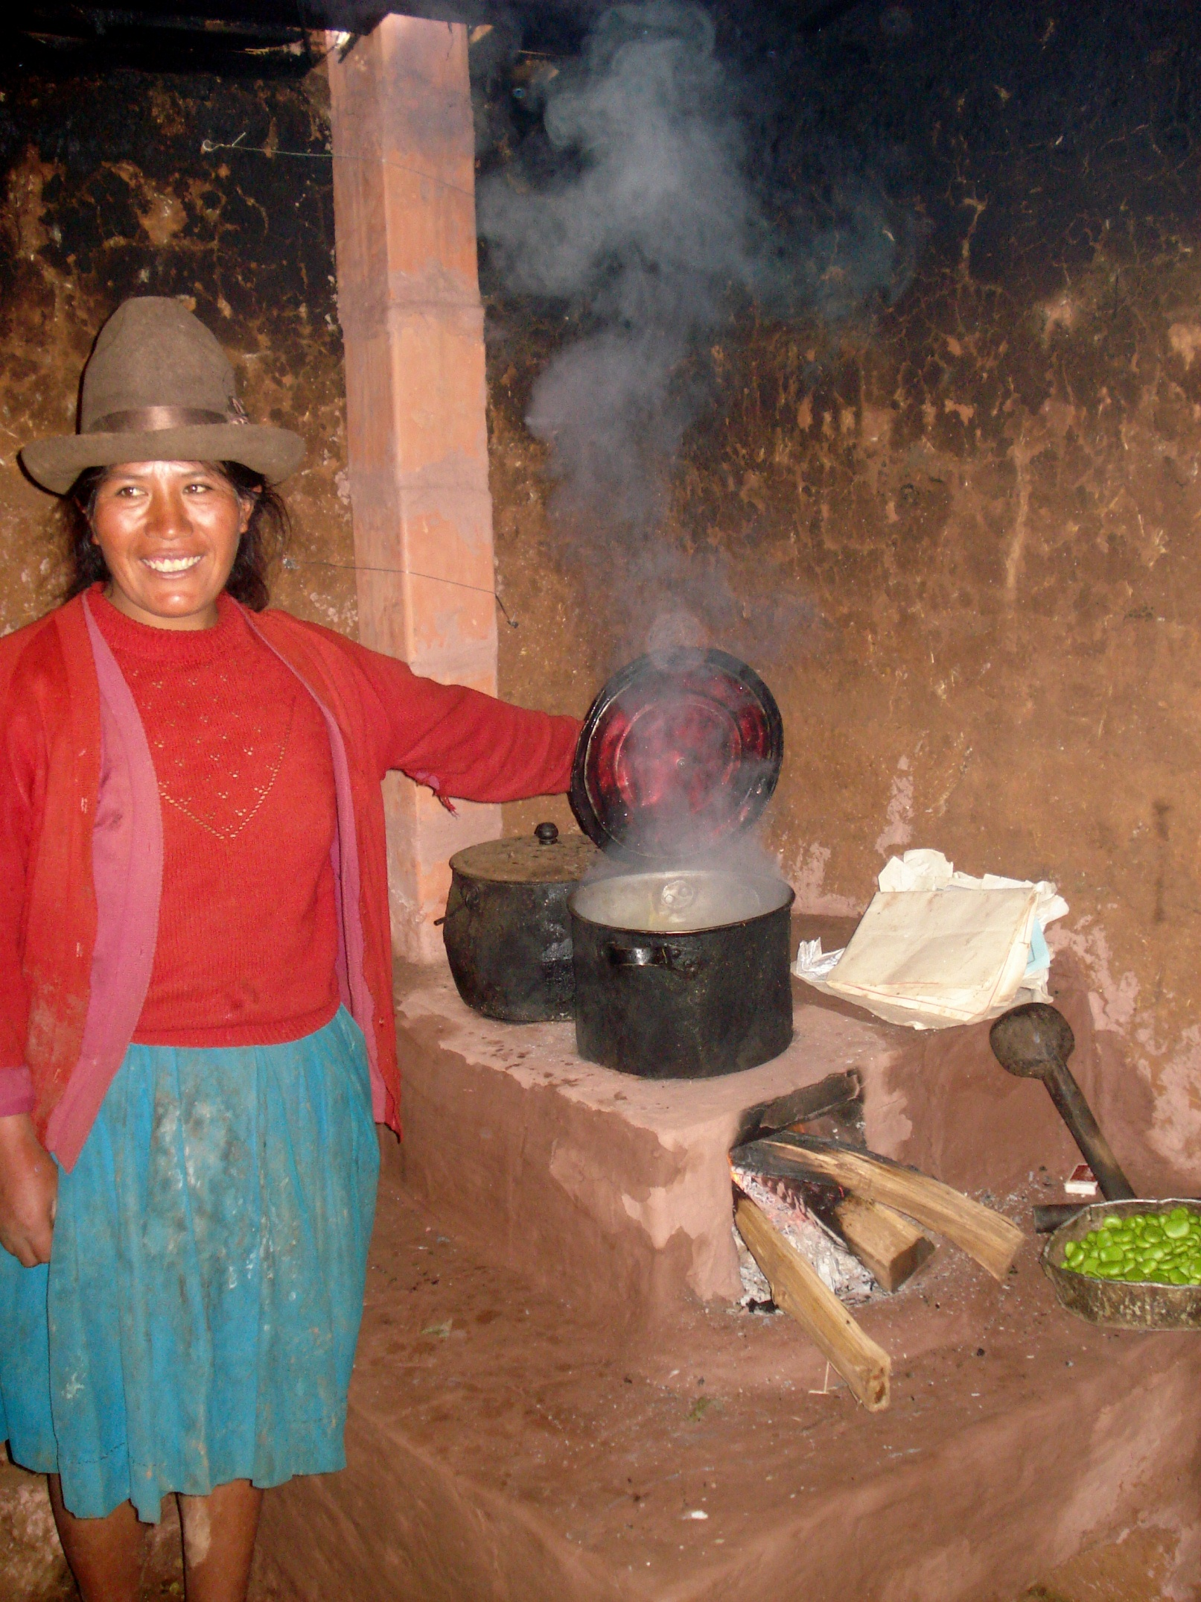

Tuesday, October 21
3-4pm (drop by)

Moore Hall 2041
Global and International Studies Conference room

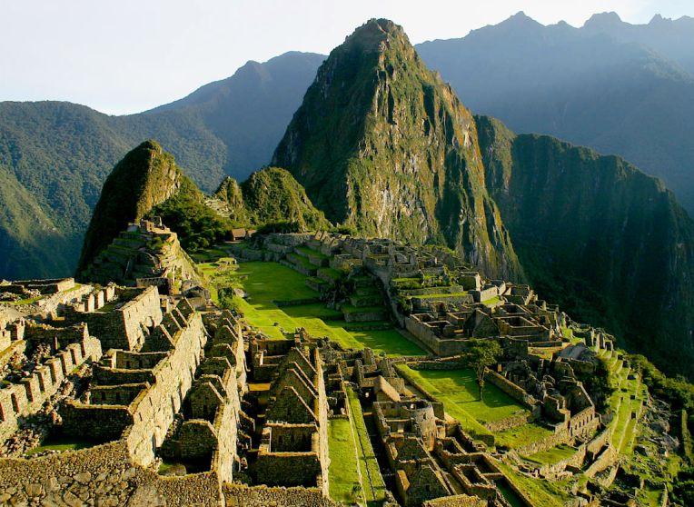

Are you interested in doing a community service project to deepen your understanding of international development? At this session, Dr. Hastings and the service provider INTRAX will provide more information about the city of Urubamba, Peru and how students will explore the issues of health care, education, small business financing and the role of women in the community. Live with a local family! Visit breathtaking Machu Picchu!

